IConnecT

Erasmus+ Project
2015-2018

Project Journal Year 3

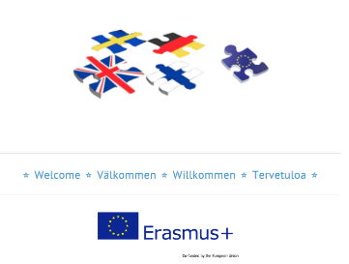

Welcome to the project journal for our Erasmus+ project on the theme of IConnecT. In this journal there is a summary of the key projects that were undertaken by partner schools as well as examples of work completed by students and photographs of the exciting and varied projects that took place. The philosophy behind the project is to improve achievement in Modern Foreign Languages and basic skills (especially mathematics) for all students through research into innovative and creative teaching strategies, especially using ICT. We hope you enjoy reading about it!
Partner schools:

Ounsdale High School, Wombourne, United Kingdom
Scheeleskolan, Köping, Sweden
Pershore High School, Pershore, United Kingdom
Gymnasium Georg Ernst, Schelusingen, Germany
Liedon Keskuskoulu, Lieto, Finland

Project Coordinators:

Sue Laffey, Ounsdale
Sandra Rosendhal, Köping
Simon Kemp, Pershore
Sieglinde Bastick, Schleusingen
Susanne Nuttunen, Lieto

Project Website

For more information about any part of this project, please visit our project website at
http://erasmusplus-iconnect.weebly.com/
Use the TAGS on the left hand side to choose which aspect of the project you wish to look at.

Year 3: Coordinators’ Meeting in Germany
When: September 2017

What happened?

Hennebergisches Gymnasium "Georg Ernst" hosted eight teachers from all partner schools from 14th to 17th September 2017. This meeting was used to plan the project work for Year 3, especially the "SEN Confidence Building" workshop in Britain.
Thursday,14th September 2017: All guests arrived and got a warm welcome
Friday, 15th September 2017: On Friday morning, after a tour of the school, the last two years of the Erasmus+ project was discussed and a plan for the final year of cooperation was approved. In the centre of interest were activities like the ongoing professional dialogue between teachers to share and discuss good practice, live lessons in Maths and in Modern Foreign Languages (MFL), the "Great Erasmus+ Bake Off" and strategies for teaching SEN. In terms of Teacher Professional Development, we discussed what sort of special needs students there are in the schools and what the schools do to support them. Each school has students with a range of special educational needs or barriers to learning. The type of support is various and includes for instance
- Additional support within mainstream lessons
- One to one support to address specific areas of weakness
- Targeted support to address underachievement
- Small group teaching to develop key skill areas
- Small group and one to one programmes to support friendship, communication and listening skills
- Counselling, advice and guidance
- Keyworkers to liaise with pupil, teachers and parents
- Academic mentors to support achievement and progress
- Assistive technology (such as word processors)
- Homework clubs and Social clubs

Although not all schools have a special training or special teachers who are responsible for SEN students, all teachers do their best to support each student depending on its individual way of learning. It is important to integrate students, especially those with problems. These discussions informed out planning for the "SEN Confidence Building" workshop in Britain in spring 2018.

In the afternoon, the guests and of course the parents and grandparents of German students were able to convince themselves of their abilities. A colourful program was presented in the auditorium, which was created in collaboration with different faculties. The bouquet of songs, poems, sketches and dances met with the great approval of the audience.

Saturday,16th September 2017: The Luther year and 500 years of the Reformation were the ideal occasion to visit the Wartburg in Eisenach on Saturday morning. In the evening we celebrated 20 years of co-operation in Comenius projects with some of the "old pioneers of school partnership". As "Hennebergisches Gymnasium" we are proud to be part of this great Comenius/Erasmus+ school partnership.

Sunday,17th September 2017: Time to say "Goodbye”
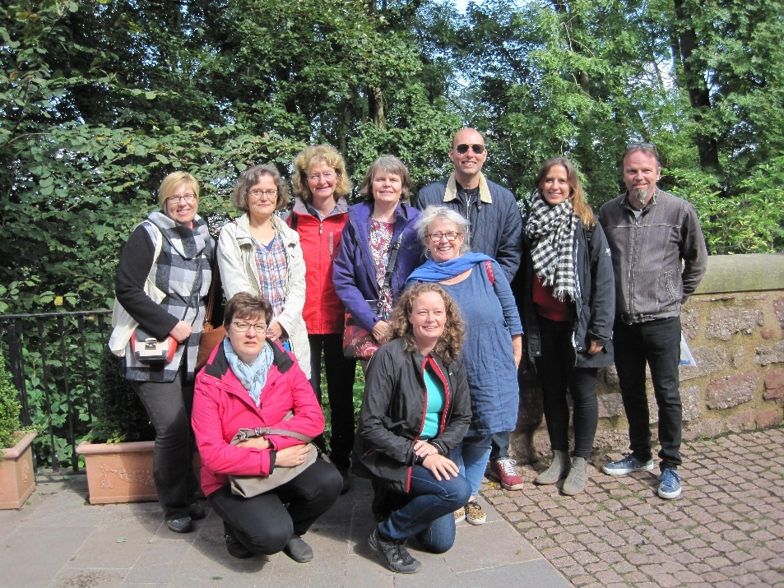

The Erasmus+ Group in Eisenach
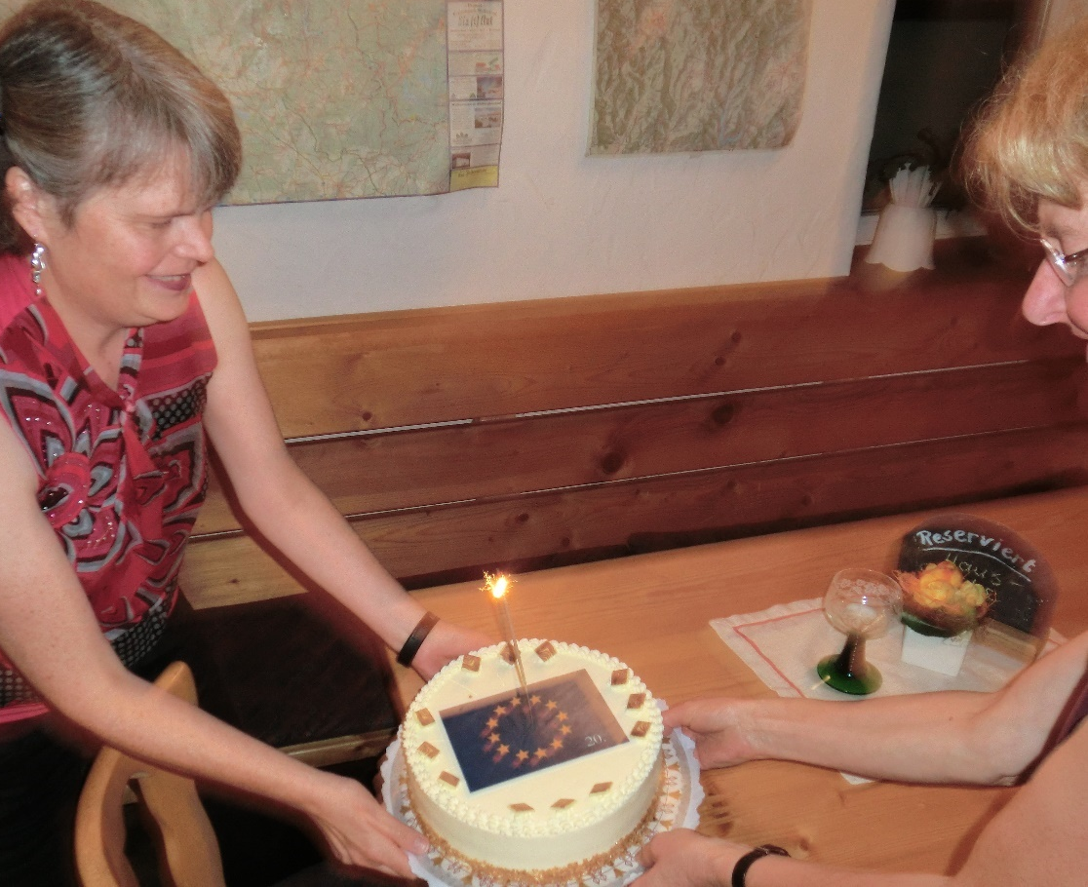

Our 20th Birthday Cake

Year 3: Maths Live Lesson and Videos
When: Autumn 2017

What happened?

Following work done combining MFL with Maths in Year 1 of our project, we wanted to develop this further in Year 3. Specifically, we wanted to improve the ability of teachers to use innovative and creative teaching strategies so that they can better engage students in their learning process and to strengthen the confidence of teachers in using ICT in their lessons.

As a result, we had hoped to persuade Maths teachers to do "Live lessons" for students both in their own schools and in other schools. However, many of our Maths teachers were not confident enough to do this, and timing of lessons was also difficult, so we adapted the plan. Some teachers were willing to do a live lesson – such as Miss Williams from Ounsdale who did a SKYPE lesson on Index Rules for her class and a class in Köping, which provided an innovative opportunity for her to communicate with teachers and students in that country.

However, other teachers preferred to do things in a pre-recorded way and, as a result, we now have a bank of videos showing how to solve various Maths problems such as Pascal's triangle and counting the area of a rectangle and a square. Links to these videos are on the project website.

For many teachers this was a new way of teaching Maths. Only Maths teachers at Ounsdale have a long history of producing videos to support the learning of students but we have now encouraged teachers across the partnership to consider this as a way forward.

If you are not good enough at mathematics yet, have a look at our website for help!!

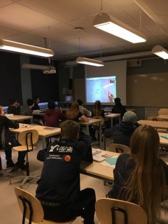 | 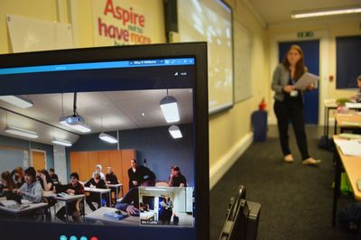
Live lesson – photo taken in Köping | Live lesson – photo taken at Ounsdale

Year 3: MFL virtual Teacher Exchange
When: Autumn 2017

What happened?

In the Autumn of 2017, MFL teachers planned and taught "live lessons" for students in other countries using ICT applications and methodologies established in Year 1 and 2. Like with the Maths project, above, we originally planned for these to be live but this proved too difficult so instead, the lessons were videoed and sent to teachers in the partner schools via the website.

Each teacher has their own way of teaching and different strategies to improve the foreign language and it is very interesting to see how teachers and students work together. The lessons are a brilliant basis for the professional dialogue between teachers to share and discuss good practice and new approaches.

For example, Pershore did a German lesson, Schleusingen a French one, Lieto prepared an English lesson and Köping showed an example for a Spanish lesson. These are now resources available for teachers in other schools to use if they wish.

Year 3: Workshop in the UK – Confidence Building for SEN students
When: March 2018

What happened?

From 3rd – 10th March our final project workshop took place in the UK. The aim of the week was for students to develop confidence and a can do attitude to life by engaging in a series of challenges and it was a big success. We specifically designed this meeting to be done by students with Special Needs of various kinds, using our usual definition of Special Needs as being any barrier to learning. As a result of this, two teachers per school attended the meeting and also most of the accommodation was in a local outdoor education centre rather than in families.

The first work day, Sunday, featured the students taking part in climbing, a high ropes course and a giant swing. There was snow on the ground and the weather was cold but this didn’t stop everyone from having a good time and everyone tried all the activities, even if they were a little scared of some of them. We finished the day by having a meal together. It was amazing how quickly everyone made friends during this day.

On Monday the group went to Pershore High School where they learned Japanese and also did some cooking – they made scones and other elements of a British afternoon tea.

On Tuesday, the group was back at the outdoor education centre where they did water based activities such as raft building, canoeing and sailing. Fortunately, the weather was a little warmer as everyone got at least a little wet. Again, everyone engaged well with the activities.

On Wednesday the group went to Ounsdale High School. They spent the day in the music department and learned how to play a variety of instruments to perform a pop song. At the end of the day they did a performance in the school hall to an invited audience.

The last work day was Thursday and everyone was back at Ounsdale. In the morning the group had to teach each other a new skill. We learned Russian and knot tying amongst other things. Later every student had to do a PowerPoint slide about the week and what they had learned. They then had to present this to the whole group. It was very interesting for us all to find out what the students had enjoyed the most (usually the outdoor activities) and what they had learned about themselves. That evening the group attended the Pershore High School production.

Finally, on Friday, there was day of relaxation. The group travelled to Stratford and visited a science museum before having some free time. That evening, everyone was able to spend time in families to learn a little more about the English way of life.

Overall this was a very successful week. The evaluation of student views can be found on the PowerPoint presentation (created by the students on the Thursday) which is on the project website and also in the evaluation questionnaires. Also to be found on the website are some details of the staff professional development which took place during the week, focussing on learning more about how students with SEN are supported in UK schools.

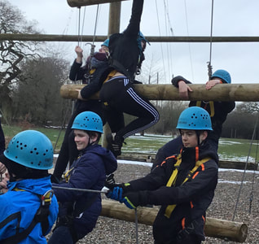 | 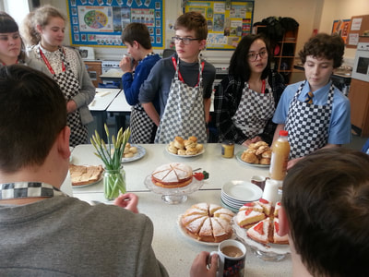
Sunday | Monday
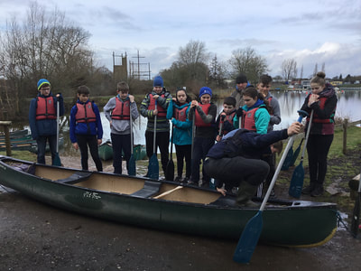 | 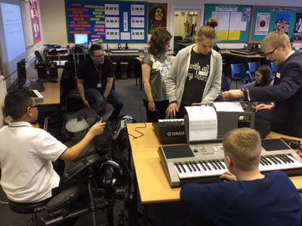
Tuesday | Wednesday
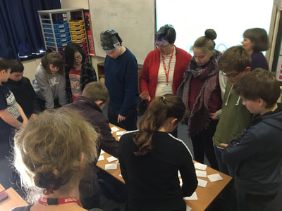 | 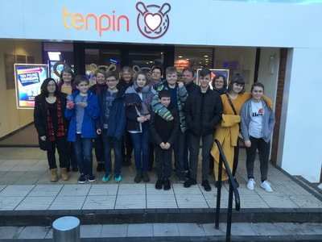
Thursday | Team Photo

Year 3: The Great Erasmus+ Bake Off
When: Spring 2018

What happened?
In the Spring of 2018 we held our Great Erasmus+ Bake off. The idea was to develop skills in Food Technology, MFL and Maths as well as social entrepreneurship. Students had to make cakes using a recipe in a foreign language then sell them at a profit, raising money for a local charity. This is what happened in each school:

Köping:
The students in Sweden baked cakes and the headteacher bought all the cakes for 400 Swedish Krone. The students were allowed to choose a charity which gets the profit and decide to donate it to an organisation called ”Never Alone” which helps people with mental illness.

Ounsdale:
Y8 students at Ounsdale made cakes in their food technology lessons on a rota. They sold these cakes at break and raised £281.55 which was donated to the Kingsway food bank which helps needy families in South Staffordshire. The class which made most money won a big tub of chocolates.

Schleusingen:
The students of the 8th grade used the celebration of the German-French Day to bake crepes in their French lesson. The students of the 8th and 9th grade baked muffins, cakes and crêpes. The money raised - 257,62€ - went to support Tambach-Dietharz Childrens' Hospice and the Tierschutzverein Südthüringene Animal Shelter

Lieto:
The students of the 9th grade baked Almond cakes, Brownies and Paradise cakes. They organized their cake sale so everybody who bought the cakes was able to speak in the MFL. All the profit (167,50€) was donated to the Mannerheim League for Child Welfare to bring Christmas spirit to local low-income families.

We are very proud that our schools have raised 773.77€ for local charities – a fantastic sum.

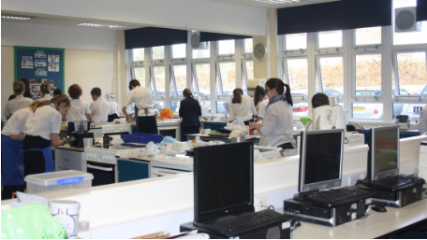
Ounsdale | Köping
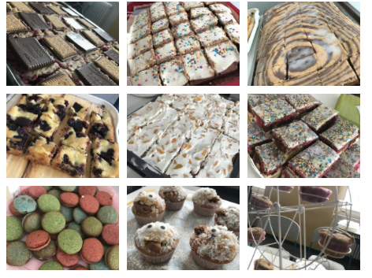 | 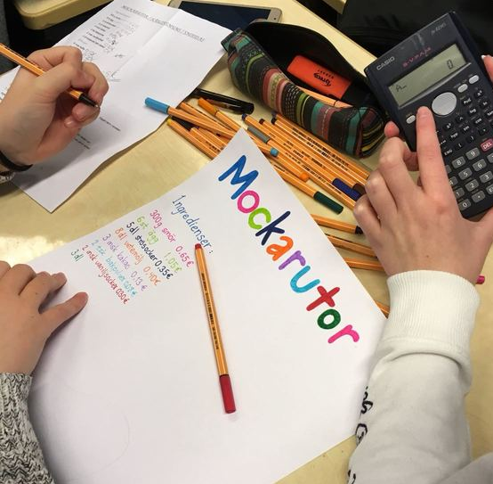
Schleusingen | Lieto

Year 3: MFL Students as teachers
When: Spring 2018

What happened?

In Spring 2018 our students had the opportunity to develop their knowledge of MFL by teaching them to others. The students worked together to create activities and resources in a different language which were then presented to their fellow students. We know that we learn best ourselves when we teach somebody a new skill so there were lots of advantages for everybody involved in this strand of the project and students were able to develop their confidence as well as their presentational skills. In all partner schools a large number of students, including SEN students, took part in the activity and devised some creative and memorable tasks for one another to complete. It looks like we have some talented teachers in our schools!

For all schools, we built upon the work in the first two years of the project and in particular we reviewed our criteria for a good MFL lesson to give students a good starting point for their activities.

In Schleusingen students produced worksheets in French, revising Food and Drink vocabulary as well as devising some fiendishly difficult past tense puzzles.

In Ounsdale students worked together in groups to devise interactive presentations which were then delivered to the rest of the class as starter activities.

In Köping students had the opportunity to learn family and weather words in German with a video lesson they produced.

In Lieto students produced a range of tasks for each other including missing song lyrics and even a kahoot puzzle!

In Pershore students created board games in French which they then played with a number of visiting Middle School students.

Take a minute to look at our website to see the great work completed by our students. Here are some examples:

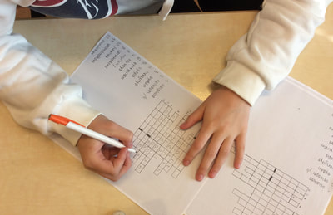
Lieto | Ounsdale
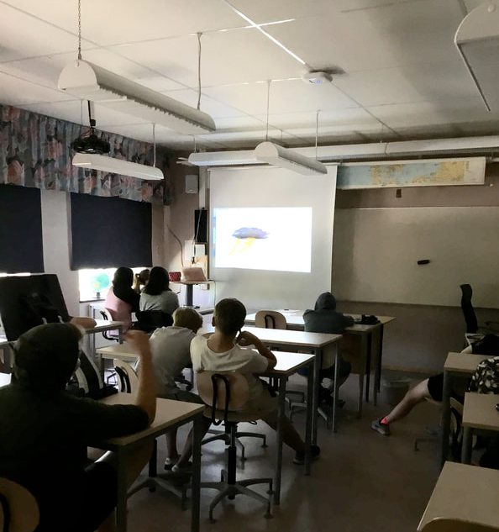 | 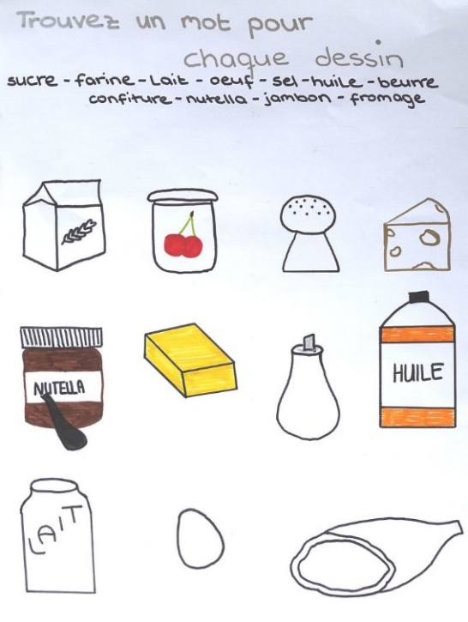
Köping | Schleusingen

Thank you
A huge thank you to everyone who has made this project possible over the last two years:
- To the Headteachers for supporting the work we do
- To the Coordinators at each school who have worked tirelessly to make our project ideas a reality
- To the teachers in a wide range of subjects who have agreed to join the project work and make it so successful
- To our students for taking part in the project so enthusiastically
- To our students’ parents for their support, especially with accommodation for meetings
- To our national agencies for their support and advice
- To the European Union for funding this fantastic opportunity

